U4 Tripper Car — Belt Tracking and One-Sided Product Loss
U4 provides a useful example of how belt position can influence where coarse product is lost from a conveyor. The inspection recorded a concern with the tail-pulley/alignment relationship, while the photographs show the belt displaced laterally relative to the supporting geometry and larger/coarse product accumulated predominantly along one side of the tripper-car route. Taken together, these observations support a relationship between the tracking condition and the directional product-loss pattern.
The photographs do not provide a dimensional alignment measurement or establish the complete mechanical reason for the belt displacement. The tail-pulley relationship, idlers, tension/training arrangement, tripper geometry and any local interference should therefore be checked using fixed references and under representative operating conditions. A separate accumulation of fines is also present around the head-pulley/tripper discharge area and should be assessed independently from the coarse-product tracking condition.
During the inspection, product loss from one side of the belt was also reported when the tripper was positioned further along its travel, which makes full-travel operating verification particularly important.

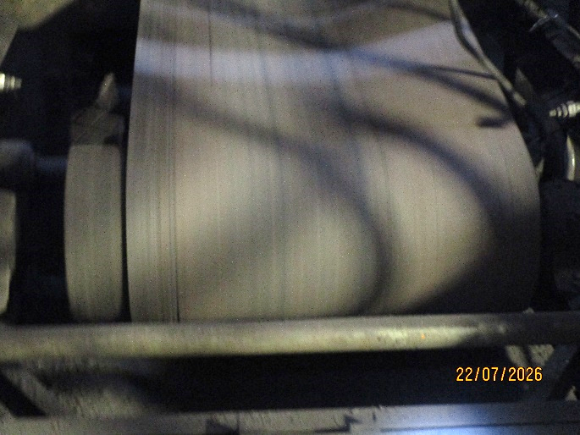  UGU4-REF-008 — Tail-end belt/pulley view supporting the alignment concern recorded during the inspection. The relationship is visually apparent but was not dimensionally measured. | 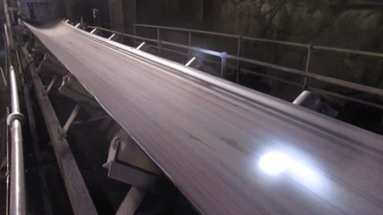  UGU4-REF-009 — Longitudinal view showing the belt displaced laterally relative to the carrying-idler/support geometry.
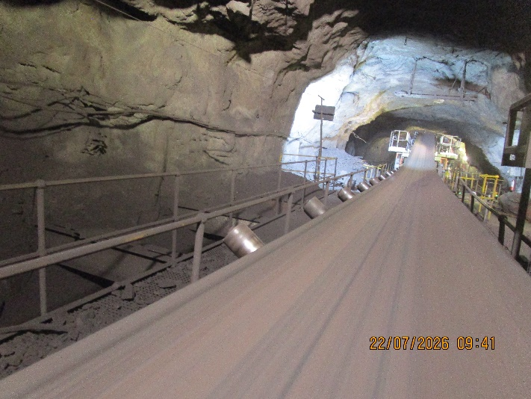  UGU4-REF-004 — Wider view showing the lateral belt-position condition extending toward the tripper-car region. | 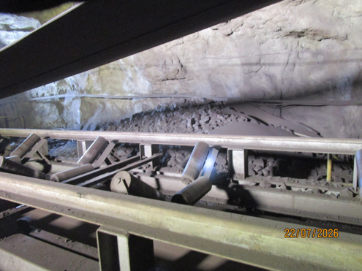  UGU4-REF-007 — Larger/coarse product accumulated predominantly along one side of the U4 Tripper Car conveyor route. The photograph shows the accumulated consequence rather than the instant at which material left the belt.
The one-sided coarse-product accumulation should be distinguished from the substantial fines deposits also present around U4. REF-005 and REF-006 show this second condition. Although both forms of accumulation occur within the same tripper-car installation, they need not share the same immediate mechanism and should therefore be assessed separately.

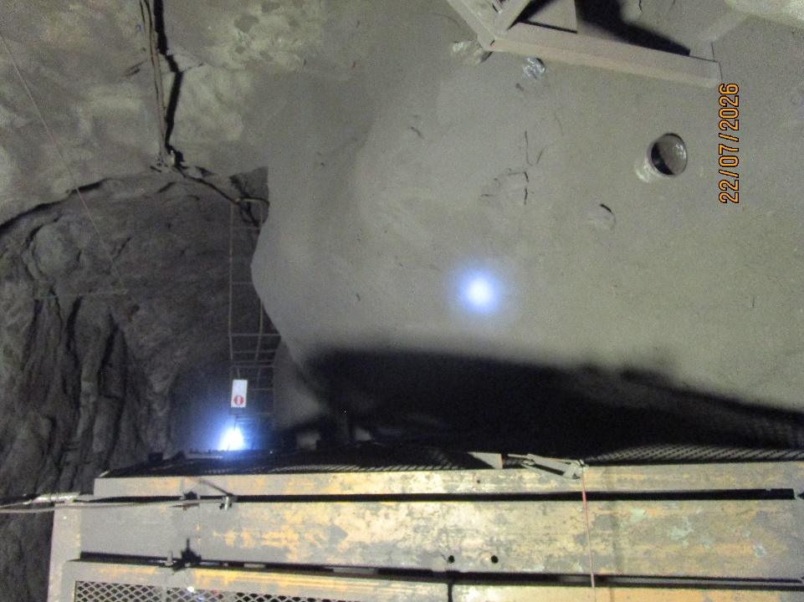  UGU4-REF-005 — Substantial fines/product accumulation beside the U4 Tripper Car, providing context for the separate fines/carryback condition. | 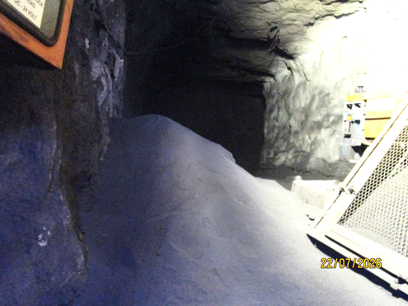  UGU4-REF-006 — Large fines accumulation in the head-pulley/tripper discharge area, showing the extent of the separate fines-related condition at U4.

OBSERVATION | A lateral belt-position/tracking condition is visible at U4, together with larger/coarse product accumulated predominantly along one side of the tripper-car route. A separate substantial fines-accumulation condition is also present around the head-pulley/tripper discharge area.
ENGINEERING ASSESSMENT | Taken together, the alignment context, visible belt displacement and directional coarse-product accumulation support a relationship between belt tracking and the observed one-sided product loss. The available evidence does not establish the dimensional alignment error or the complete mechanical cause of the tracking condition. The separate fines accumulation should be investigated on its own merits, including the local cleaner/discharge arrangement.
RECOMMENDED NEXT ACTION | Record the as-found belt and tail-pulley relationship using fixed, repeatable references and inspect the relevant pulley, idler, tension/training, tripper geometry and local-interference conditions. Where a contributing mechanical condition is confirmed, correct it and then observe the belt through the normal tripper travel under representative loading to confirm that an acceptable centred relationship is maintained. The one-sided coarse-product loss and the separate fines condition should then be reassessed independently to determine whether any further containment or cleaner-related action is required.

